**PYTHON POD CREATION USING KUBERNETES**

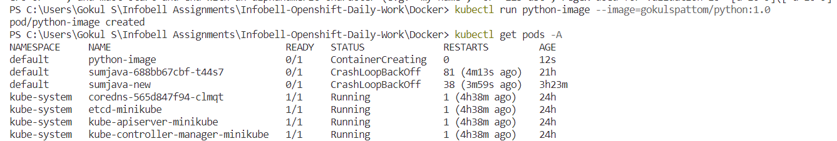







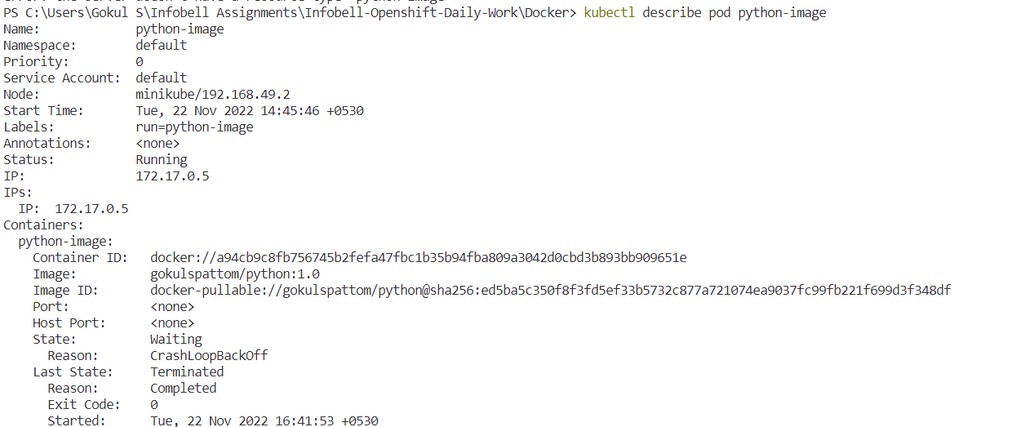

**VIEWING SERVICES**

